**Using MATLAB to Measure the Diameter & Area of an Object within an Image**

By Akansh Maurya

Electrical Engineering (Sophomore)

Institute of Engineering & Technology, Lucknow

Date: 8th January 2019

**Objective**

Through this application note you will be able to write a MATLAB script file to import an image, segment the image in order to isolate the desired object from its background and then use the MATLAB functions that come with the Image Processing Toolbox to determine the objects diameter.

**Hardware Used:**

Operating System**:** Windows 10

Processors: Intel i5 8th Gen

RAM: 8GB

Graphics Card: Nvidia Geforce 1050ti

**Software**

MATLAB 2016a

Image Processing Toolbox (Downloadable application)

**Process**

All the method and process used in this project are commented in the script of MATLAB file.

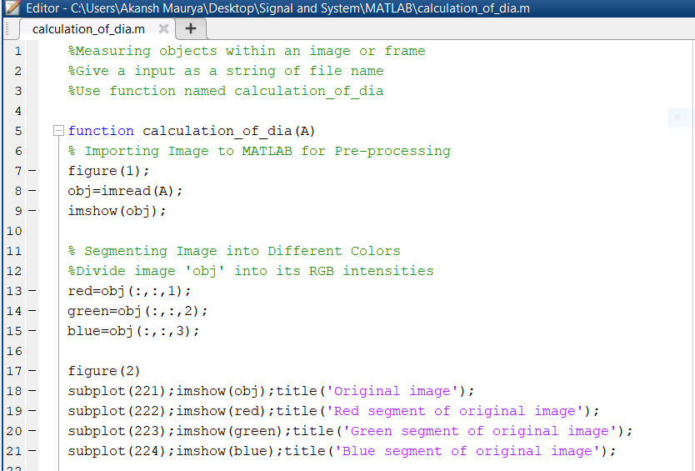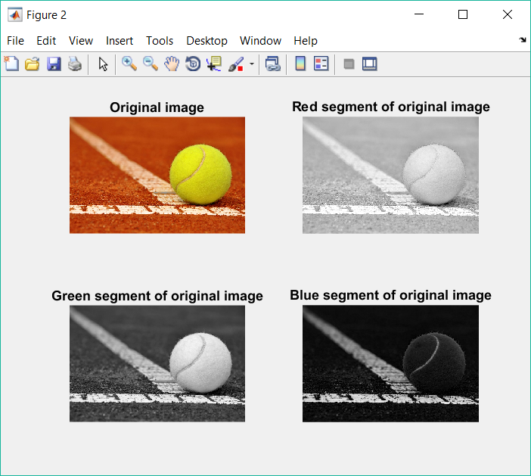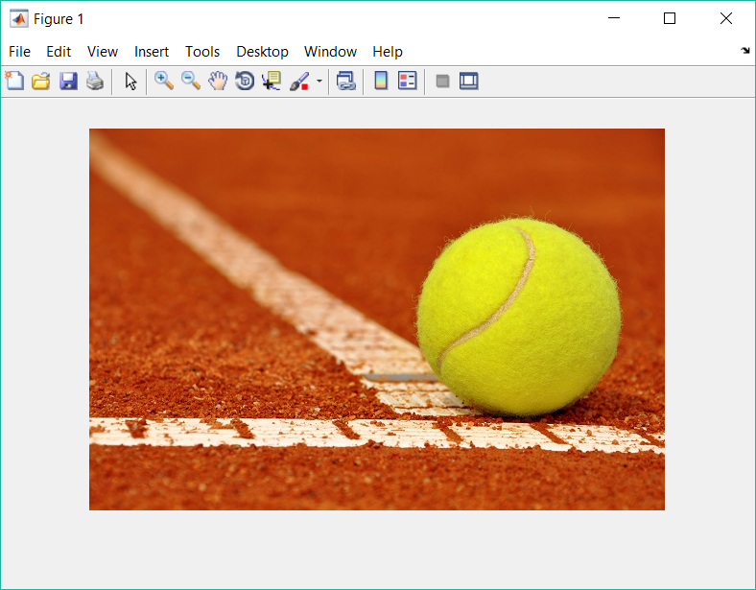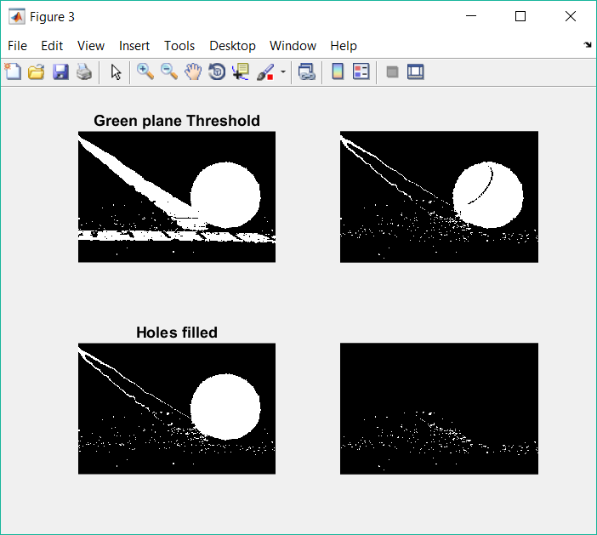

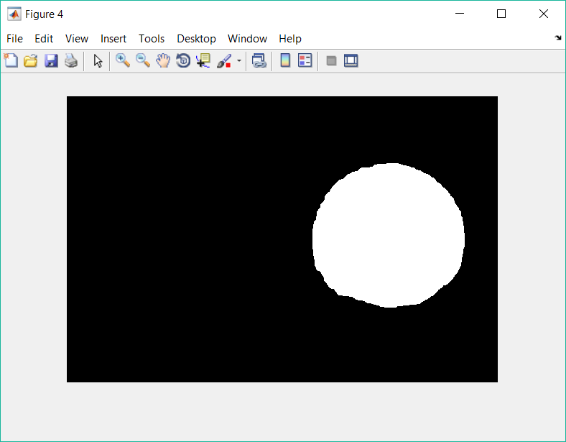

**Results**

We can see in command window that the value of area and diameter is given.

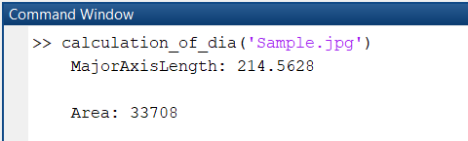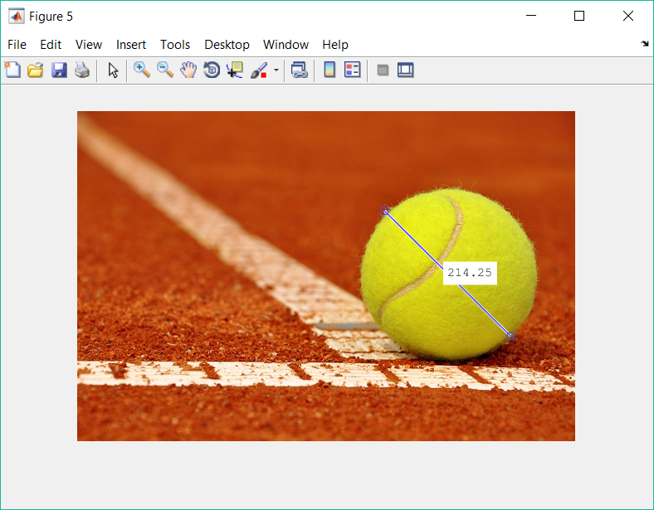

We can validate the result by physically calculating the diameter.

Also we can note that there is some error in the Diameter calculation, it may be occurred during image processing but this small error can be neglected.

**References**

1. Image Processing Made Easy. Perf. Andy Thé. Mathworks. N.p., 15 Oct. 2014. Web. 07 Nov. 2014.

<http://www.mathworks.com/videos/image-processing-made-easy81718.html>.